ANNUAL River Creed Catch Return –

(Please note this is document has 2 pages)

Dear Member. In order to fulfill our commitment to the Scottish Government, Stornoway Angling Association, as leaseholders of the Creed fishery are obliged to return complete catch information at the end of each season. It is imperative that all members complete the enclosed catch return form (including NIL returns) and return by post to SAA c/o 8a Aird, Point HS2 0EU or email to info@syangling.com by the 11th Nov annually. Many thanks in anticipation of your co-operation.

Please record your name and membership number on both sheets to assist administration.

_________________________________________________________________________________________________________________________________

Name: _______________________________________ Membership Number: ______________

Address: __________________________________________________________________

River Creed Season Ticket Holder Catch Return Form - Season 20_______

(Part 1 – only needs to be completed if you fish early season)
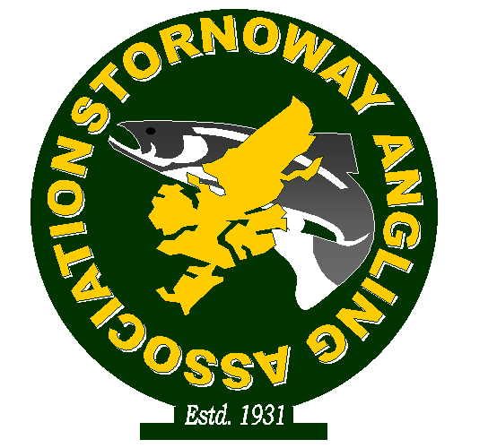
 |  | Salmon  (7lbs +) |  | Grilse  (< 7lbs) |  | Sea Trout  (1lb +) |  | Finnock |  | No. of trips in month
 |  | Number | Total wt | Number | Total wt | Number | Total wt | Number | Total wt | Total Only
Apr | Catch & release  ONLY
May | Catch & release  ONLY

Name: _______________________________________ Membership Number: ______________

Address: __________________________________________________________________

River Creed Season Ticket Holder Catch Return Form – Season 20_____

(Part 2 – must be returned for any fishing activity)
 |  | Salmon  (7lbs +) |  | Grilse  (< 7lbs) |  | Sea Trout  (1lb +) |  | Finnock |  | No. of trips in month
 |  | Number | Total wt | Number | Total wt | Number | Total wt | Number | Total wt | Total Only
Jun | C&R only
July | C&R only
Aug | C&R only
Sept | C&R only
Oct | C&R only

